# How to communicate between two WPF windows

## Introduction

In some WPF app scenarios, there needs message interactions between different windows. Here is an implementation based on event.

## Prerequisites

* *Visual Studio 2013*

## Running the Sample

* Download and open the solution in Visual Studio
* Build and run the app

1. there will be 2 windows running: the Agent Window && the Customer window,

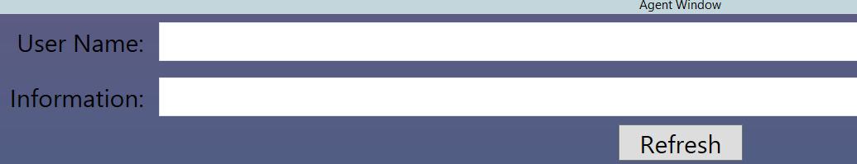

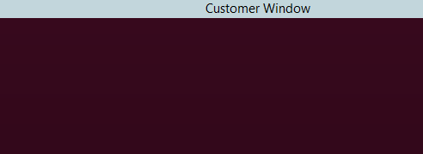

1. type information in the Agent Window and click Refresh button, information will update the Customer window

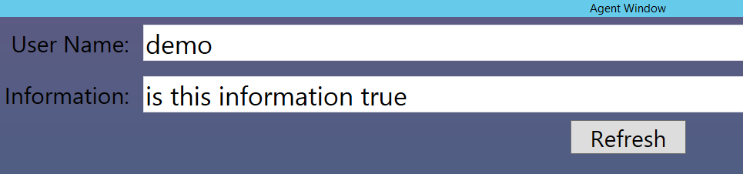

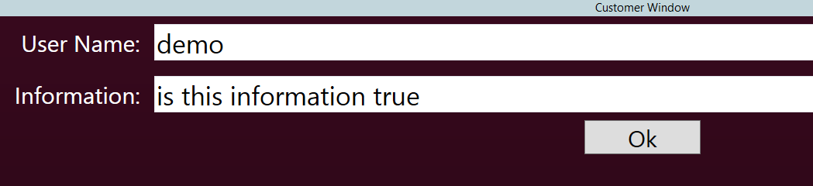

1. click the Ok button, a confirmation button will prompt to the Agent window screen.

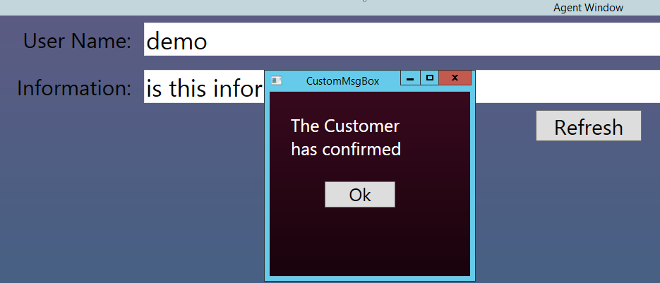

## Using the Code

* Create a **WPF** project in **Visual Studio**
* Create Two Windows, establish the event to handle message routing, and establish event handler in two windows, further detailed implementation, please check in the project.